ShopWise User Guide

# Overview of ShopWise

## Introduction

**ShopWise** is an Android **Shopping List App**, designed for **10” Tablets**, with consideration for the less technical savvy savvy user in mind. Although designed primarily for 10” tablets, **ShopWise** can be used on smaller tablets and even phones. However, the display size can then be difficult due to the reduction in size.

**ShopWise** is intended to, always be free, always be free from Advertising and always be free from your personal information being recorded and passed to other parties.

**ShopWise** is intended to offer functionality over display wizardry. **ShopWise** has no icons and bar scrolling list uses no gestures/ fancy finger-work.

## The Shopping List (the main purpose of ShopWise)

The prime function of **ShopWise** is to present a **Shopping List** ordered by **Shop**, then **Aisle** (location within a Shop) and then **Product**. Each level, **Shop**, **Aisle** and **Product** (more correctly **Stock**, as will be clarified later) has an order field from 1-9999 (lower order appears first).

The **Shopping List** includes a heading that details the **Total Cost** of the Items in the Shopping List, the **Amount Spent** and the **Amount Remaining to be Spent**.

A simple click (touch) of the **BOUGHT** button, that each row includes, mimics the placement (purchase) of the respective **Product** (Stock) into the **Shopping Basket**; when the quantity purchased equals the quantity ordered the relevant row in the list is checked-off.

The **ADJUST** button, allows an item to be adjusted, the quantity, price and description of the Product can be changed. Checked-off items can be unchecked by adjusting the quantity to be more than 0 conversely adjusting the quantity to 0 will check-off an item.

The **DELETE** button removes the respective row from the Shopping List without recording any purchases.

The **DONE** button returns to the Main Display (similar to using back).

The **TIDY** button removes all of the Checked-Off rows.

*A brief history of purchases is kept. That is the first purchase date, the last purchase date and the total purchased are recorded for use by the Rule Suggestion and Rule Accuracy features.*

### An example of the Shopping List:

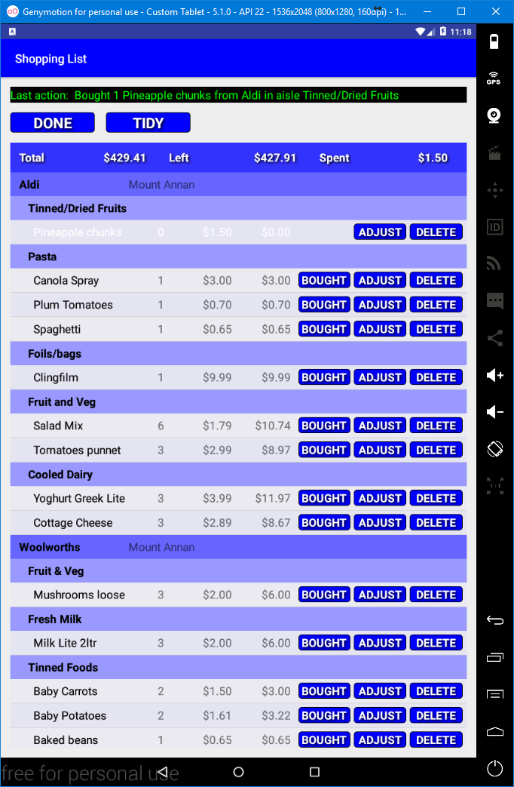

Note! **BOUGHT** button hidden when checked-off

BOUGHT, ADJUST and DELETE Buttons

A **Checked-Off Row**

(*i.e all the required quantity have been purchased*)

Row showing **Product**, quantity to get, **price** for 1 and total price.

Shop Heading (for each Shop)

Aisle Heading (for each Aisle)

**Messages**

**Totals Heading**

*From the above you can see the first* ***Shop*** *is Aldi, the Second Woolworths. Aldi has* ***Aisles****, Tinned/Dried Fruits, Pasta, Foil/Bags, Fruit and Veg and finally Cooled Dairy. Within* ***Pasta*** *are Products, Canola Spray, Plum Tomatoes and Spaghetti. It is the respective Order field that determines the sequence.*

*e.g.* ***Shop*** *Aldi has an* ***Order*** *of* ***1000****, Woolworths* ***1100*** *so* ***Aisles*** *and* ***Products*** *in Aldi are displayed before* ***Aisles*** *and P****roducts*** *in Woolworths (change Woolworths to 900 and aisles and products in Woolworths would appear first). Likewise* ***Aisles*** *have an* ***order*** *on a per* ***Shop*** *level (Aisles are specific to a Shop). Furthermore,* ***Products*** *(actually Stock as will be learnt) have their own* ***order*** *on a per* ***Aisle*** *basis.*

# ShopWise Terminology

Few would not understand what a Shop or an Aisle is. However some may be more used to using the term store for a shop and want to find something at a counter rather than an aisle. Further complications can arise as words can often have multiple meanings e.g. shop could mean a place where you can but produce or it can mean to go and buy something. As such this section tries to clarify what terms mean when using **ShopWise**.

* **SHOPS** – Where products are sold.
  + **Shops** have a name, a city (to distinguish between like name shops such as chains) and an **Order** (to determine the order in which they appear in the **Shopping List**).
* **AISLES** – A location within a shop where products can be obtained.
  + **Aisles** have a reference to the **Shop**, a name and an **Order** (to determine the order that they appear within the **Shop** in the **Shopping List**).
  + It may not necessarily be an aisle. Some shops may only serve you from a counter where you ask where for what you want (e.g. a Deli Counter).
  + You may want to split actual Aisles into section, conversely you may wish to only have 1 **Aisle** for a **Shop**.
  + In short **ShopWise** provides flexibility.
  + At least 1 **Aisle** is required per **Shop** to be meaningful within **ShopWise** (*i.e. you can define a shop without any Aisles. However that Shop cannot then have Stock (purchasable products) and thus nothing can be ordered from such a shop*).
* **STORAGE** – A location, likely at Home, where you store products e.g. the pantry, the fridge etc.
  + A **Storage** item has a name and an **Order** (to determine the order that the **Storage** location appears in the **CHECKLIST**).
  + **Storage** facilitates the **CHECKLIST** feature, allowing you to check what you have in an ordered fashion.
  + Again **ShopWise** is flexible, you may wish to just have a single **Storage** location, such as Home. However, at least 1 **Storage** is required.
  + Note **Storage** is often used to refer to a **Storage** location, rather than all **Storage** locations.
* **PRODUCTS** – An item that would be stored at home.
  + It should be noted that there is a distinct difference between a Product and Stock, the latter being more specifically a product assigned/located to an Aisle within a Shop.
    - A **Product** has a name, a Storage Location and a Storage Order.
* **STOCK** – **Products** assigned to an **Aisle** within a **Shop** with a price/cost attached. i.e. Something that you can buy from a specific Shop.
  + In **ShopWise** **Stock** has different attributes than a **Product**.
    - A **Stocked** Item references an **Aisle** (*and thus implicitly a* ***Shop***).
    - A **Stocked** item also references a **Product** (*and thus implicitly the Products attributes, name, storage location and storage order*).
    - A **Stocked** item has other fields such as the first and last purchase date, the cost/price, the number purchased, an indicator to signify if it should appear in the checklist, and the quantity to check for.
    - A **Product** can be **Stocked** multiple times. However, each has to be unique (*thus the aisle has to differ /be unique*).
  + **Stock** can be considered as a purchasable product.
* **ORDER –** Lists Stock, according to **Product name** allowing items to be added to the **Shopping List** in an ad-hoc way.
  + e.g. you may have just used a can of Baked Beans and wish to add them to the **Shopping List**.
  + Generally if the **Stock** has been marked as appearing in the **CHECKLIST** you could wait until you use the **CHECKLIST** feature. However, either way can be used.
  + **ORDER** displays a list of all **Stock**. The list includes the number already in the Shopping List.
  + The list can be filtered to quickly find the relevant **Stock** item(s).
  + **Order** (note capitalised rather than all uppercase) is also used as the name of a field for Shops, Aisles, Stock and Products for ordering lists (**Shopping List** and **Checklist**).
  + The sort order can be changed by clicking a heading.
  + Clicking a heading when already sorted by that heading, results in the sort order toggling between ascending and descending order.
  + **ADD** adds 1 of the respective item to **the Shopping List**.
  + **LESS** removes 1 of the respective item from the **Shopping List** (*note* ***LESS*** *cannot reduce the number below 0*).
* **CHECKLIST** – Lists **Stock**, set as to appear in the **Checklist**, according to **Storage location** and then **Product Order** (*sort order is fixed i.e. clicking headings will not change the sort order*).
  + The List includes the **Level** to be checked against.
    - E.g. you may wish to buy a can of baked beans if you do not have three cans at home. Thus the **level** could be set to 3.
  + **Check-Off** button checks-off an item in the list (**UNCHECK** button replaces the **Check-Off** button and the **ADD** and **LESS** buttons are hidden).
  + **ADD** adds 1 of the respective item to the **Shopping List**.
  + **LESS** removes 1 of the respective item from the **Shopping List** (*cannot reduce to below 0*).
* **SHOPPING –** Displays the Shopping List (this has been covered previously).
* **RULES –** Entries that allow regular automated or prompted additions to the **Shopping List** on a regular basis.
  + Regularity is determined by two fields a **INTERVAL** field and a **MULTIPLIER** field.
  + **Interval** is one of **DAYS**, **WEEKS**, **FORTNIGHTS**, **MONTHS**, **QUARTERS** or **YEARS**.
    - Note using Months for a day of the month that is 29-31 can be confusing due to some months not having that many days.
  + **Multiplier** is a number, an Integer. It is used in conjunction with **Interval** to produce the regularity/frequency of or prompts.
    - E.g. an **Interval** of **WEEKS** and a **Multiplier** of **3** equates to Each 3 Weeks.
  + **Prompted** Rules appear, if there are any, when **SHOPPING** is clicked.
    - Initially a **Dialog** is displayed as a reminder that **Prompted Rules** will be displayed. Clicking on **Proceed** displays the list of **Prompted Rules**.
    - **ADD** adds to the **Shopping List** and marks that occurrence as done (setting the date of the next occurrence).
    - **SKIP** skips adding that occurrence to the Shopping List and marks the occurrence as done (setting the date of the next occurrence).
    - **NOTE!** subsequent occurrences may become active and then appear in the List.
      * This would be the case if the regularity of the **Prompted Rule** is greater than the period between uses of the **Shopping List**.
      * E.g. If you setup a rule to be daily but only displayed/used the Shopping List on a weekly basis, then there would be 7 occurrences but each would appear individually only after it’s previous occurrence had been added or skipped (i.e. the date of the next occurrence is worked out only when an occurrence is actioned (added or skipped).
    - **DONE** will proceed to the **Shopping List** without either adding or skipping any of the displayed rules (so the occurrences would still be available).
      * i.e. this is an exception to the general use of **DONE** that returns to the previous display.
* **TOOLS** – Features that are complimentary to the main features of **ShopWise** or have a secondary nature of use.
  + **BACKUP** – Backup and restore of the **ShopWise Database**.
    - With careful use could be used to utilise multiple Databases.
  + **RULES** – Suggestion of Rules (**SUGGEST**) and Accuracy Checking of Rules (**CHECK**) based upon shopping history.